Login Page: Multiple logins will be supported as seen below.

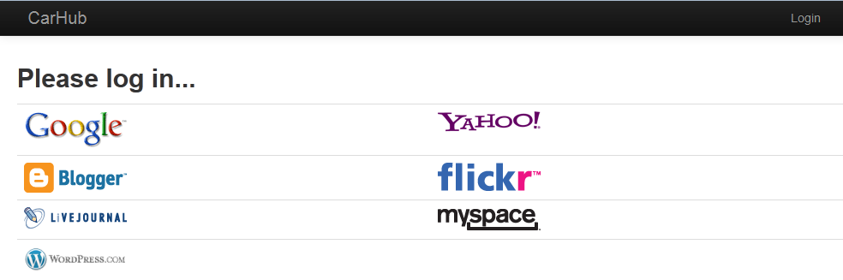

Garage: Each user will have their own Garage where they can keep track of their cars.

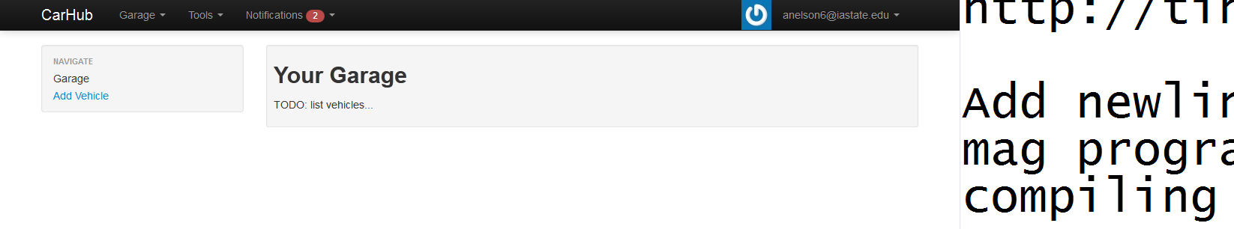

Car Page: Each car will have their own page that lists the details.

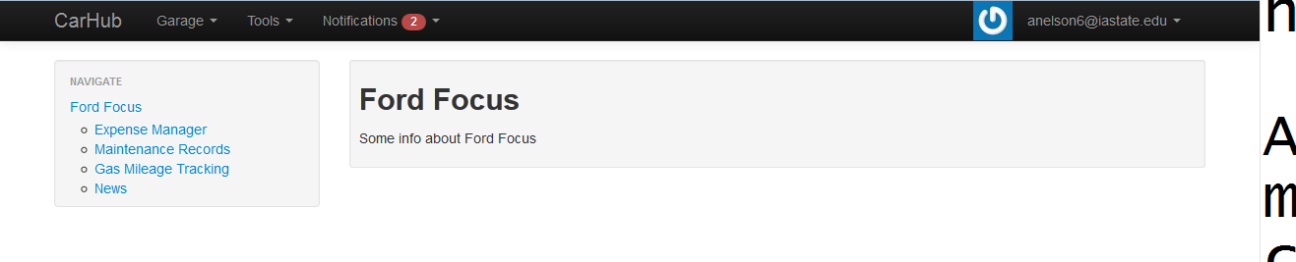

Notifications in the navbar: These will be similar to FaceBook notifications about the user’s cars.

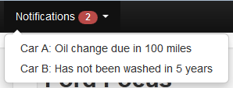

Expense Manager: Each user will have an expense manager for their cars where they can input their own records.

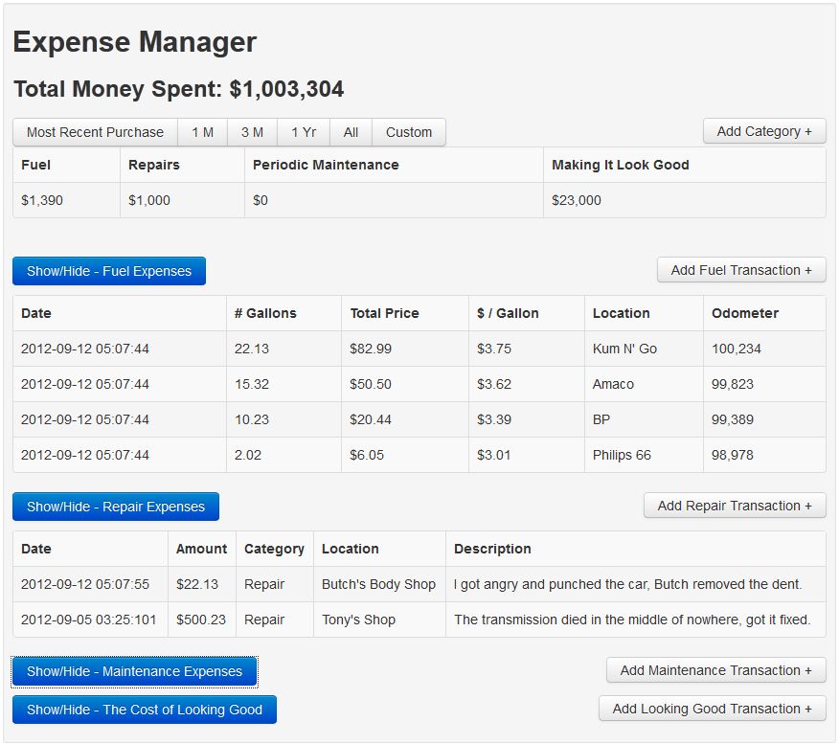

Maintenance Records: Users will be able to input maintenance records.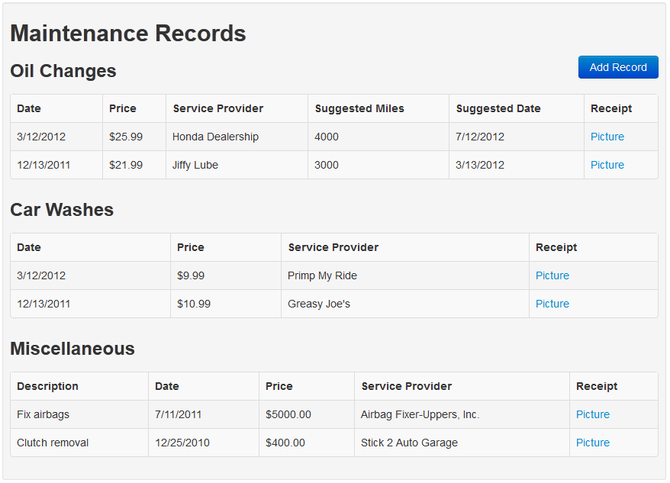

Gas Mileage Tracker: Users can input specific gas mileage after each fill-up to track how much they are spending.

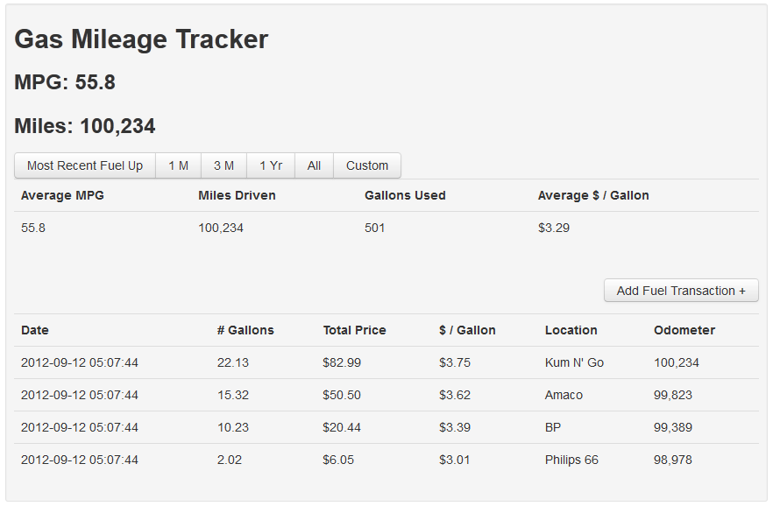

News: Users will have a news feed about their car.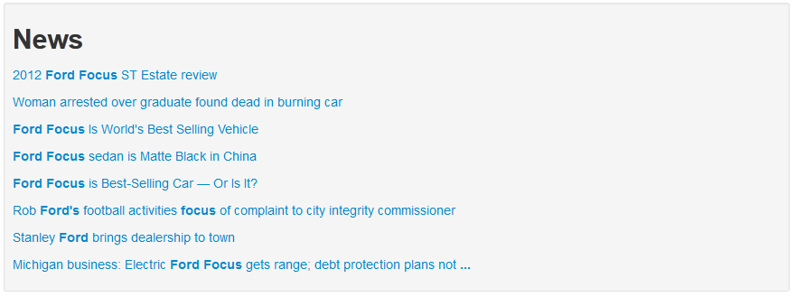

Nearby Gas Prices: Users will have the ability to search for gas prices from their current location or with a zip code.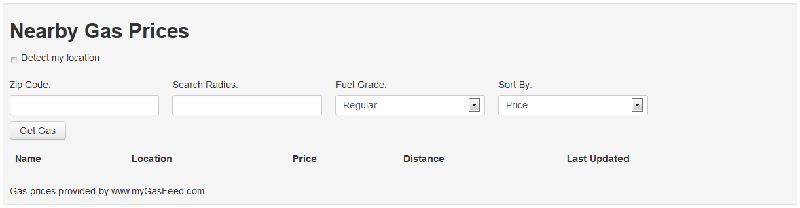

Trip Planner: Users will have the ability to interact with a trip planner to plan their route.